Baby Monitor
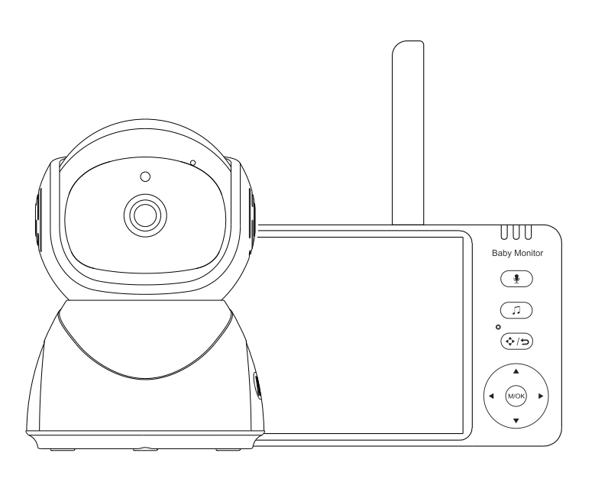



ABM570 User Manual

Dear Customer,
We are truly grateful that you chose our product, we hope that you will be happy upon enjoy the fantastic quality and our services. Meantime, Your any requirements, suggestions and expectations that will be most helpful for our product improved and created new to fit your standards.
This user’s manual can guide you to understand how to operate this product and solve any problem, that customers may encounter in using our products. Please read carefully before using the device.
☠ Warning

DANGER - Keep the adapter cable away from the baby to avoid a choking hazard from entangling the baby's neck.

Keep the baby camera unit and cable out of the reach of children more than 3 feet or 1 meter away.

Do not place the camera or power supply in a child's cot/crib.
Camera settings and usage
- Fix the camera in a place where can be observed well of children/babies.
- Place the camera on a flat surface such as table, desk or shelf.
This baby monitor meets all standards related to electromagnetic fields and safe-use when operating in accordance with the instructions of user guide. Therefore, please read the user guide carefully before using the device.
- Must be assembled by adult.
- This baby monitor can be used for adult guardianship.
- Store this user guide for future reference.
- Do not cover the baby monitor with towel or blanket.
- Keep the baby monitor away water.
- Keep the baby monitor away heater, humidifier & others.
- Do not use other charger or power adaptor which may damage the device.
- Do not touch the plug with a sharp or metal object.
Important notes for installing a baby monitor
- When using, must check wireless Transmission smoothly connected between camera and the displayer, The wireless Transmission distance is affected by environmental conditions.
- Any heavy metal or home appliance will be block wireless signals transmit, such as refrigerators, metal doors or reinforced concrete.
- The strength of signal may be attenuated by solid buildings (such as walls), radios or electrical equipment (such as televisions, computers).
- If the signal lost, try to move the device to different location indoors.
- Do not put displayer and camera together within 1.5 meters, otherwise, it will cause howling.

Unit Package：
* Camera
* Displayer
* User Manual
* Power Adapter+ power-charging cable
（Longer charging cable for camera）
Please use a DC 5V adapter, preferably the original one.
*Bag of screws
Index
1.1 DISPLAYER OVERVIEW 5
1.2 DISPLAYER STATUS BAR ICON 6
1.3 DISPLAYER MENU ICON 6
1.4 CAMERA OVERVIEW 7
2.1 HOW TO TURN ON DEVICE 7
2.2 PAIRING 7
2.3 CHECKING THE IMAGE OF BABY CAMERA 8
3.1 CAMERA BUTTON FUNCTION 8
3.2 NIGHT VISION MODE 8
3.3 INSTALLATION.....................................................9
4.1 INTERCOM MODE 9
4.2 VOLUME ADJUSTMENT 9
4.3 FEEDING REMINDER (ALARM) 9
4.4 LULLABY 10
4.5 SYSTEM TIME SETTING 10
4.6 TEMPERATURE DISPLAY 10
4.7 CAMERA DISPLAY SELECTION 11
4.8 VOX SETTING 12
4.9 DISPLAY BRIGHTNESS 13
5. PTZ REMOTE CONTROL......................................13
6. CAMERA IMAGE ZOOM IN..............................13
7. POWER LEVEL 14
8. SIGNAL 13
9. CLEANING 14
10. FAQ & TROUBLESHOOTING 14
11. SPECIFICATION 15

- PRODUCT OVERVIEW

1.1 DISPLAYER OVERVIEW
Power Switch

Reset Key

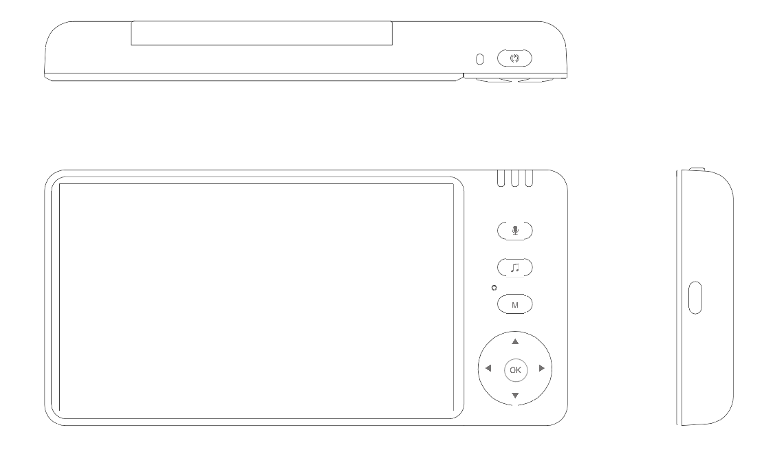

Indicator Light

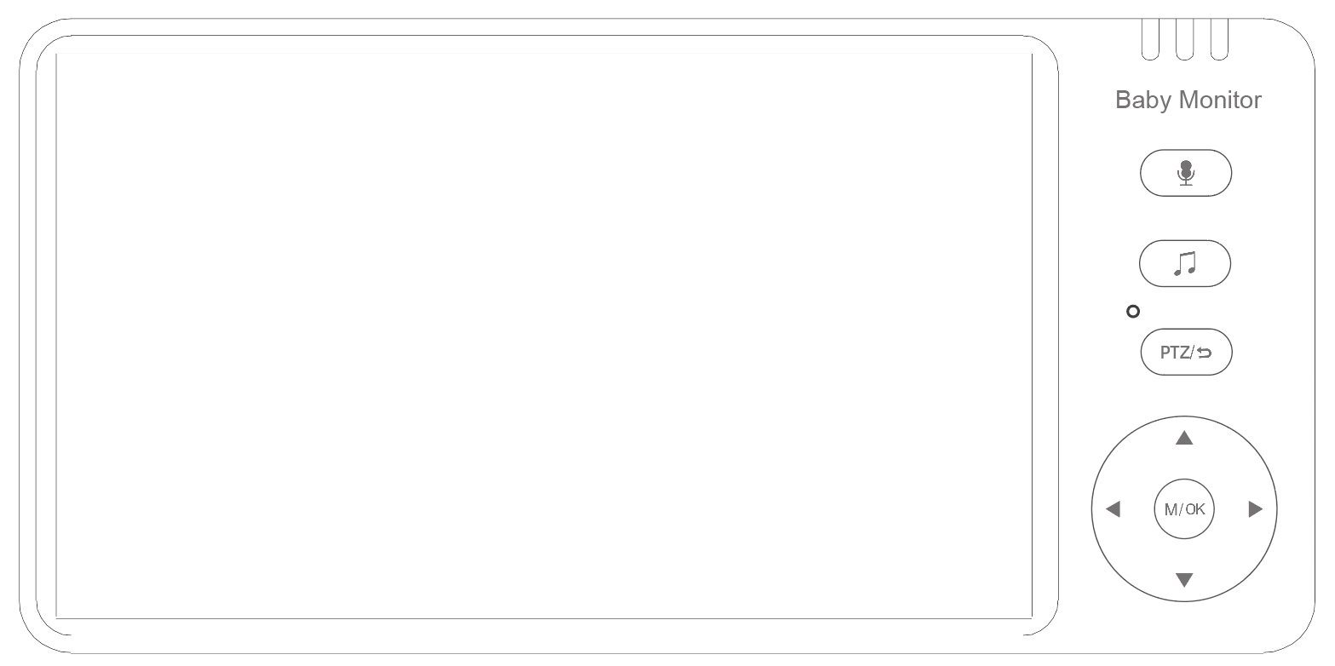

Audio Key

Music Key

Mic


PTZ /Back

Direction Key/Shortcut Key

Menu/OK

Power Port

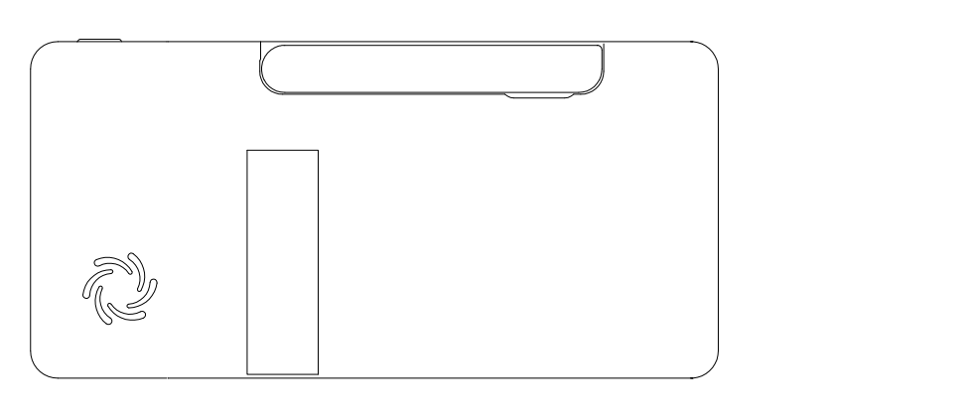
Antenna

Bracket

Speaker

1.2 DISPLAYER STATUS BAR ICON
 | SIGNAL LEVEL (5 Levels)
 | NO SIGNAL
 | CAMERA 1
 | CAMERA 2 (customized)
 | CAMERA IMAGE ZOOM IN 2 TIMES
 | CAMERA SWITCH
 | LULLABY TURN ON /OFF
 | VOLUME SETTING (6 levels can be set)
 | INTERCOM MODE
 | NIGHT VISION MODE
 | CRYING DETECTION（HIGH,MED,LOW ）
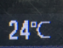 | BABY ROOM TEMPERATURE DISPLAY
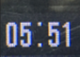 | SYSTEM TIME
 | BATTERY POWER

1.3 DISPLAYER MENU ICON
 | Feeding Reminder Time Setting  （Can Set 5 Alarms） | 
 | Lullaby Selection  (8 Lullabies) | 
 | System Time Setting
 | Temperature Setting(℃/℉ ,Temperature alarm on/off/High temperature warning/low temperature warning setting) |   
 | Camera Selection  (add/delete/switch) | 
 | VOX Sound  Detection Setting | 
 | Camera zoom in / out | 

1.4 CAMERA OVERVIEW
MIC

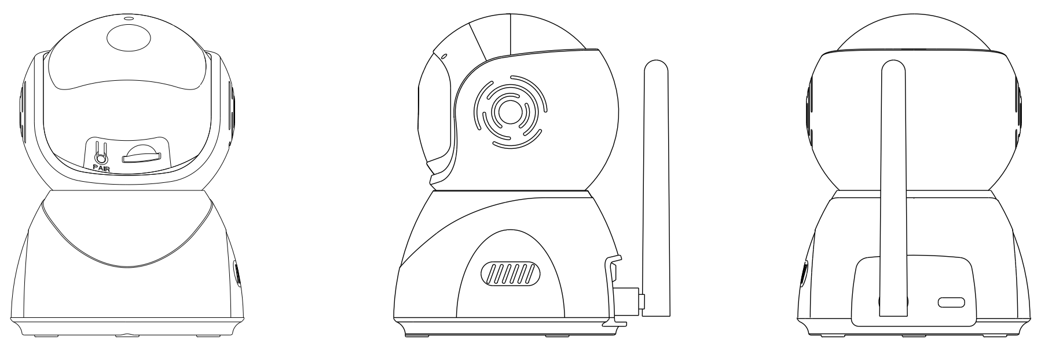
PAIRING KEY

INFRARED LIGHT

LEN

POWER PORT

SENSOR

SPEAKER

ANTENNA

- OPERATION
  - HOW TO TURN ON DEVICE
The baby monitor provides two power adaptors + power-charging cables. One is to connect the camera, the other is to connect displayer for charging battery.
- The adapter is available for AC-100-240V input. The camera will auto-turn-on after plug adaptor in, the blue indicator will be light-on (At the night mode it will automatically turn off).
- Pull-out antenna first, press the power button of displayer for 3 seconds to turn it on/off. Displayer is with battery, when battery is low-power, please plug adaptor in for recharge

2.2 PAIRING
Once the camera and the displayer are both turned on, they will be Auto-connected, If not, follow the steps as below:
- Turn on the displayer and press menu key  . Pressor 
to select camera and press to confirm. In the pop-up bar, press
button to select and press to confirm, and then press or to
chooseor  to pair. At this time, the blue indicator light of the displayer device will flash and a prompt 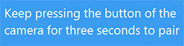will appear on the displayer device screen. The blue indicator light stops blinking when the device is paired successfully.
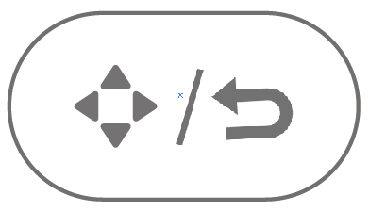
If no device is paired for 30 seconds, it will automatically exit the pairing mode, or you can press and hold for 1.5 seconds within 30 seconds to exit the pairing mode directly.
- When the camera is power–on and turned-on, keep pressing the pairing key for 3 seconds, then, the blue light will flash quickly. It means that the camera is now in the pairing mode. Once the camera has connected with the displayer, the indicator light will turn off. Now the displayer can show the image that the camera captures.
If there is no device pairing for 1 minute, it will automatically exit the pairing mode.
(Note: One camera can only be connected to one monitor. If the pairing fails several times in a row, please contact the after-sales service or local dealer.)

2.3 CHECKING THE IMAGE OF BABY CAMERA
When both the camera and the displayer are normally turned on, the displayer should be able to show the image from the camera (If the displayer does not show the image please check the pairing condition.).
- Please check those are with power in advance.
- If the connection fails, please re-pair according to the 2.2 PAIRING instruction.
- Press the key to enter the menu, and select the camera you want to watch.
- CAMERA USAGE
3.1 Camera button function
Keep pressing the buttonfor 3 seconds to enter the pairing mode. It will quit in a minute then need pair again.
3.2 NIGHT VISION MODE
The camera is equipped with 1 piece high-intensity infrared LED light, which helps to capture clear images in the dark. When the built-in optical sensor detects that the ambient light is weak, the infrared LED will become automatically light up. The screen of the displayer will be shown in black and white color, and the icon will be displayed in the status bar at the top of the screen.
3.3 INSTALLATION
- Place the camera at the area as you want to monitor.
- Adjust the camera view angle by turning the direction key , , or till a satisfactory image as you like on the displayer.
- THE DISPLAYER MENU
4.1 INTERCOM MODE
While you want to two-way talkback, please press the key mode, then you can talk with your little baby. And release the key when the conversation is over. Meanwhile, the camera system will enter intercom mode after releasing the key of the displayer.
4.2 VOLUME ADJUSTMENT
（1） Press the key or to adjust a larger or smaller volume.
The volume has 6 levels for option.
4.3 FEEDING REMINDER (ALARM)
（1）Press the key to enter the main menu.
（2）Press the key or to choose .
（3）Press the key or to select the alarm time (0.5h/1h/2h/3h/ 4h) for the feeding reminder. Then press the key to confirm. Press the key to exit the menu.
If the alarm time is set, the displayer will beep every 0.5h/1h/2h/3h/ 4h, and the flashing feeding mark will appear on the screen. Press any key to cancel feeding reminder.

4.4 LULLABY
（1）Press the key to enter the main menu.
（2）Press the key or to choose .
（3）In the pop-up menu bar, press the key or to select the lullaby, and press the key to confirm. To play all the music in a loop, select and press the key to confirm. Press the key or to switch to other settings， or press to exit the menu.
（4）Press the music keyto play the lullaby, and press again to turn off the lullaby, long press to play all the music in a loop.

4.5 SYSTEM TIME SETTING
（1）Press the key to enter the main menu.
（2）Press the key or to choose  .
（3）In the pop-up menu bar, press the key to choose in turn the hour, minute, second, and press the key or to adjust in turn the hour, minute, second. Press the key or to switch to other settings, or press to exit the menu.

4.6 TEMPERATURE DISPLAY
（1）Press the key to enter the main menu.
（2）Press the key or to  .
（3）In the pop-up menu bar, press the key or to select  or , press the key to confirm. Press the key or to switch to other settings, or press
to exit the menu.
（4）In the pop-up menu bar, press the key or to select  and press the key to enter the sub-menu of setting the alarming temperature.
（5）Press the key or to set a high, low or turn on warning temperature...
Press the keyorto turn on or off  temperature alarm sound. Undermode, there’s only an icon or prompt no beep alarm, under mode, there’s an icon or prompt also a beep alarm.
Press the key andto set the temperature value to be warned（℃ setting range 28℃~37℃，℉setting range 82℉~98℉）. If the current ambient temperature is higher than the set warning temperature, the system automatically prompts a high temperature warning.
Do the same to set the low warning temperature（℃ setting range 0℃~26℃，℉setting range 32℉~78℉）. If the current ambient temperature is lower than the warning temperature, the system automatically prompts a low temperature warning.
（6）The screen will show temperature status bar from temperature sensor at back of camera. When the baby’s room temperature is higher over setup temperature, the screen will appear red mark on the screen and warning alarm.
While the temperature is lower than setup temperature, the screen will appear blue mark and warning alarm.
Meanwhile, above or below the set temperature will emit Beep alarm sound, and press any key to cancel Beep sound. If the temperature is not restored to the set temperature range, the Beep alarm sound will still be emitted 30 seconds later.

4.7 CAMERA DISPLAY SELECTION
（1）Press the key to enter the main menu.
（2）Press the key or to choose ，press the key or to choose , or , then press the key to enter the sub-menu .
（3）Select , then press the key to choose or for pairing. After the pairing is successful, the displayer will show the image from  or  .
（4）Select to enter delete mode, and then press to delete or ，it will prompt  or , select to delete, select not to delete, if delete successfully, the icon convert to, “no-camera-connection” will be reminded.
（5）Select , then press the key to see the sub-menu, and choose the or to view the corresponding image. Or you can choose to enter cyclic mode, and the image from the cam1 to cam2 will switch in every 15 seconds.

4.8 VOX SETTING
VOX detection: Turn on the VOX mode, the display screen will auto light off after 30 seconds. When the ambient volume of camera is louder than the setup value, the screen will auto light up.
（1）Press the key to enter the main menu.
（2）Press the key or to choose  .
（3）Press the key or to select or , then press the key to confirm the setting.
（4）Even in the VOX-off mode, short press the key  to enter VOX mode in a shortcut way (the screen will be turned off, but it will keep transferring sound from the camera).
Note: At the VOX turned off, press the key , and the screen will be keep light on without auto light on/off. The sound is still heard from the camera at any time. This mode is suitable for baby is playing while adult needs to leave for a moment.
When the VOX mode is turned on, the screen and sound will be auto light on/off in 30 seconds. When the ambient sound of the camera is louder than setup value, the screen will become light up and the speaker will make a sound. This mode is suitable to use at night.
4.9 DISPLAY BRIGHTNESS
（1）Press the keyor to adjust the brightness  directly. It has 6 levels.
5. PTZ REMOTE CONTROL
Short press the key to turn on remote control mode, then press the direction key to adjust the camera rotation angle.
- Press key, adjust camera to see upper view from displayer.
- Press key, adjust camera to see down view from displayer.
- Press key, adjust camera to see left view from displayer.
- Press key, adjust camera to see right view from displayer.
6. CAMERAM ZOOM IN
（1）Press the key to enter main menu.
（2） Press the key or to choose , then press or to select zoom in,or , then press to confirm, press the key to exit the menu.

7. POWER LEVEL
The mark 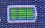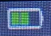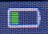 shows the current power level, the mark is lower power level and will 5 consecutive beep sound alarming, the beep sound will keep reminding LOW BATTERY.
- SIGNAL
(1) Signal mark. If there is a large signal tower base station or high power signal interference equipments in the current environment, it may cause interference to Transmission and the mark will be appear. When the signal disconnected for 5 seconds, the mark 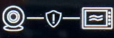 will be appear and flashes, and the monitor will make beep sound for 5 times. After the 5 times of beep sound, the monitor will only leave the mark flashing. Now the monitor is disconnected with the camera.

- CLEANING
Clean the device with a slightly damp cloth or an antistatic wipe. Never use detergents or abrasive solvents.
Cleaning and maintenance
- Do not use thinner, other solvents or chemicals to clean any part of the product, which will damage to the product. This damage is not covered by the warranty.
- Do not expose the product to high temperatures, humidity, or strong sunlight, and do not get it wet.

10. FAQ & TROUBLESHOOTING
1. Q: Why is the signal in the room is bad?
A: a. Check if the receiving antenna of the displayer terminal is turned on;
b. Due to wall of houses is different materials, which will block 2.4G signals, When the signal is not satisfied, the place of display shall be moved.
2. Q: Why there is always some noise in the background?
A:It is impossible to eliminate all the noise. This kind of howling has always been a problem in the audio field. Please keep displayer and camera separate over 1.5 meters.
Tip: The microphone of the receiver and camera cannot be the opposite. That is the reason why some users get confused when they operate the devices and always get noise in the background. This phenomenon is an uncontrollable factor.
3.Q: Why the temperature is not precision shown on the screen?
A: a. There is a difference in indoor air circulation.
b. The main reason is that the thermistor has a ±1℃ deviation, and there may be shielding around the thermistor, resulting in a difference.
4.Q: How to eliminate howling?
A:Please keep your receiver and camera separate in 1.5 meters away or more.
Tip: The microphone of the receiver and camera cannot be the opposite. That is the reason why some users get confused when they operate the devices and always get noise in the background. This phenomenon is an uncontrollable factor.
11. SPECIFIACATION
Technical Parameter
Model | ABM570 | Display Size | 5-Inch
Sensor | CMOS 1/4 | Camera | 1280*720P
View Angle | 75 Degree | Transmission method | 2.4GHz FHSS
Battery | 3500 mAh | Transmission Distance | 300M  (Open Space)
Monitor Power Consumption | 1.3W | Temperature Detection | Support
Camera Power Consumption | 1W | Cry reminder | Support
Working Temperature | -20℃~65℃ | Lullaby | Support
Material | ABS | Feeding Reminder | Support
Camera Size | D80*115mm  (D*T) | Night Vision | Support
Monitor Size | 150*74*17mm  (L*W*T)

