Baby Monitor


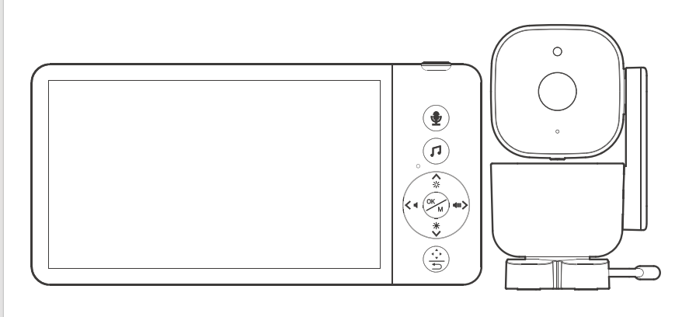

ABM720S User Manual

Dear Customer,
We are truly grateful that you chose our product, we hope that you will be happy upon enjoy the fantastic quality and our services. Meantime, any requirements, suggestions and expectations that will be most helpful for our product improved and created new to fit your standards.
This user’s manual can guide you to understand how to operate this product and solve any problem, that customers may encounter in using our products. Please read carefully before using the device.
☠ Warning

DANGER - Keep the adapter cable away from the baby to avoid a choking hazard from entangling the baby's neck.

Keep the baby camera unit and cable out of the reach of children more than 3 feet or 1 meter away.

Do not place the camera or power supply in a child's cot/crib.
Camera settings and usage
- Fix the camera in a place where can be observed well of children/babies.
- Place the camera on a flat surface such as table, desk or shelf.
This baby monitor meets all standards related to electromagnetic fields and safe-use when operating in accordance with the instructions of user guide. Therefore, please read the user guide carefully before using the device.
- Must be assembled by adult.
- This baby monitor can be used for adult guardianship.
- Store this user guide for future reference.
- Do not cover the baby monitor with towel or blanket.
- Keep the baby monitor away water.
- Keep the baby monitor away heater, humidifier & others.
- Do not use other charger or power adaptor which may damage the device.
- Do not touch the plug with a sharp or metal object.

Important notes for installing a baby monitor
- When using, must check wireless Transmission smoothly connected between camera and the monitor, The wireless Transmission distance is affected by environmental conditions.
- Any heavy metal or home appliance will be block wireless signals transmit, such as refrigerators, metal doors or reinforced concrete.
- The strength of signal may be attenuated by solid buildings (such as walls), radios or electrical equipment (such as televisions, computers).
- If the signal lost, try to move the device to different location indoors.
- Do not put monitor and camera together within 1.5 meters, otherwise, it will cause howling.

Unit Package：
* Camera
* Monitor
* User Manual
* Power Adapter+ power-charging cable （Longer charging cable for camera）
Please use a DC 5V adapter, preferably the original one.
* Bag of screws
Index

1. PRODUCT OVERVIEW 5
1.1 DISPLAYER OVERVIEW 5
1.2 DISPLAYER STATUS BAR ICON 6
1.3 DISPLAYER MENU ICON 7
1.4 CAMERA OVERVIEW 7
2. OPERATION 8
2.1 HOW TO TURN ON DEVICE 8
2.2 PAIRING 8
2.3 CHECKING THE IMAGE OF BABY CAMERA 9
2.4 HOW TO CONNECT THE CAMERA TO THE APP 9
3. CAMERA USAGE 13
3.1 PAIRING BUTTON 13
3.2 INFRARED LED 13
4. BUTTONS OF THE MONITOR 13
4.1 INTERCOM MODE 13
4.2 LULLABY 13
4.3 CAMERA ROTATION 13
4.4 VOLUME ADJUSTMENT 14
4.5 DISPLAY BRIGHTNESS 14
5. THE DISPLAYER MENU 14
5.1 FEEDING REMINDER (ALARM) 14
5.2 LULLABY 14
5.3 TEMPERATURE DISPLAY 15
5.4 VOX SETTING 15
5.5 CAMERAM ZOOM IN 16
5.6 CAMERA DISPLAY SELECTION 16
5.7 SETTINGS 17
6. POWER LEVEL 19
7. SIGNAL 19
8. CLEANING 19
9. FAQ & TROUBLESHOOTING 20
10. SPECIFIACATION 21

- PRODUCT OVERVIEW

1.1 DISPLAYER OVERVIEW
Reset Key

Power Switch

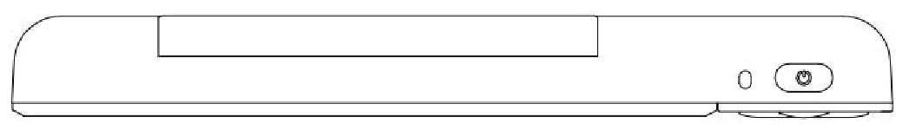

Indicator Light

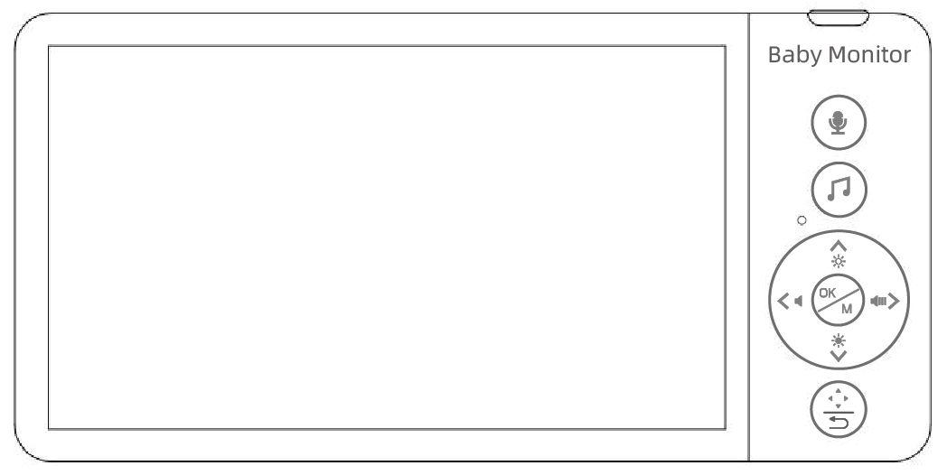
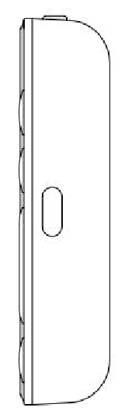
Audio Key

Mic

Music Key

Direction Key/Shortcut Key

Menu/OK

PTZ /Back

Power Port

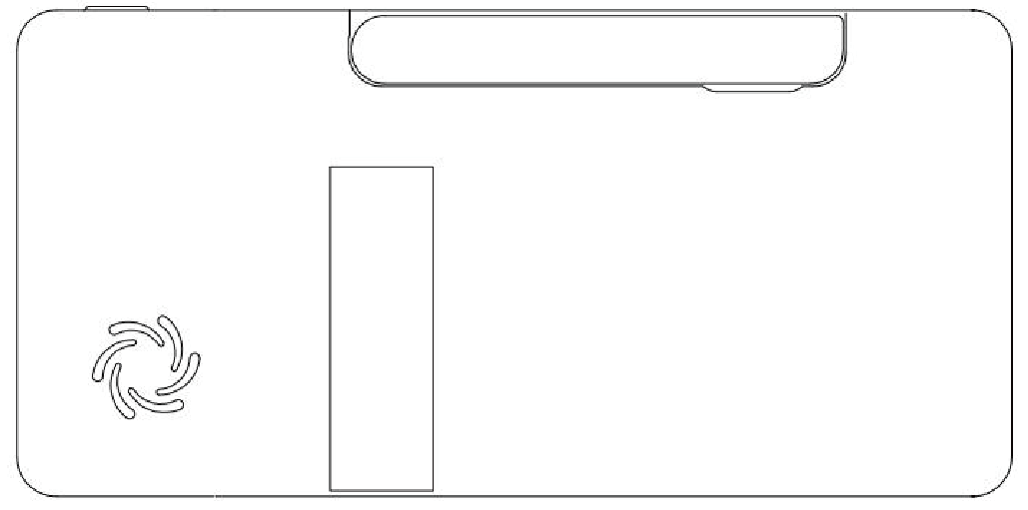
Antenna

Bracket

Speaker

1.2 DISPLAYER STATUS BAR ICON
 | SIGNAL LEVEL (5 Levels)
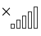 | NO SIGNAL
 | CAMERA 1 WIFI SIGNAL
 | CAMERA 2 WIFI SIGNAL
 | CAMERA 1
 | CAMERA 2 (customized)
 | CAMERA IMAGE ZOOM IN 2 TIMES
 | CAMERA SWITCH
 | LULLABY TURN ON /OFF
 | VOLUME SETTING (6 levels can be set)
 | INTERCOM MODE
 | NIGHT VISION MODE
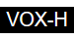 | CRYING DETECTION（HIGH,MED,LOW ）
 | BABY ROOM TEMPERATURE DISPLAY
 | SYSTEM TIME
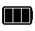 | BATTERY POWER

1.3 DISPLAYER MENU ICON
 | Feeding Reminder Time Setting  （Can Set 5 Alarms） | 
 | Lullaby Selection  (8 Lullabies) | 
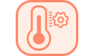 | Temperature Setting(℃/℉ ,Temperature alarm on/off/High temperature warning/low temperature warning setting) | 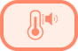
 | VOX Sound Detection Setting | 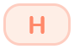
 | Camera zoom in / out | 
 | Camera Selection  (add/delete/switch/wifi config) | 
 | Settings(Time/Volume/Brightness/Language/Automatic brightness/WiFi switch/Auto tracking switch/Light source frequency/Camera working indicator light switch/TF card format | 
 | APP download（APP Store/Android）

1.4 CAMERA OVERVIEW
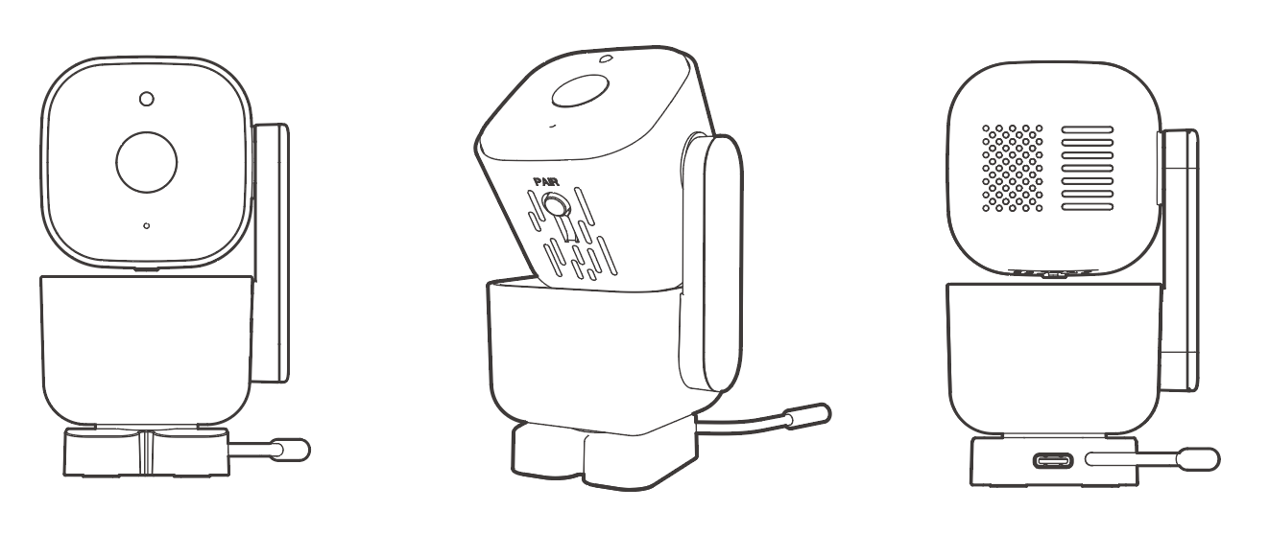
POWER PORT
SPEAKER
TEMPERATURE SENSOR
PAIRING BUTTON
MIC
CAMERA LEN
LIGHT SENSOR

- OPERATION

2.1 HOW TO TURN ON DEVICE
The baby monitor comes with two power adaptors and two USB charging cables. One is to connect the camera, the other is to connect monitor for battery charging.
Camera: Connect the camera to 110-240V AC outlet or USB port, the camera will be turned on automatically,the blue indicator light will be light-on . Unplug the camera to turn it off.
Monitor: Pull-out antenna first, press and hold the Power Switch of the monitor for 3 seconds to turn it on or off. Please charge the monitor when you start to use it for the first time.

2.2 PAIRING
As the monitor and camera were paired in advance, once they were turned on, they will be connected automatically. If not, follow the steps as below:
(1)Turn on the monitor and press menu button  . Pressor to select camera . In the pop-up bar, press button to select and press to confirm, and then press or to chooseor  to pair. At this time, a prompt 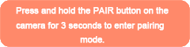will appear on the monitor screen, press and hold the pairing key on the camera for 3 seconds, when they paired successfully you will see the image from the camera on the monitor, and the camera symbol becomes  or.
(2)The camera can be paired to maximum 2 monitors, if you want to add the second camera please follow the steps as above.
(3)If the camera status is or but there is no image show on the monitor, select  and chooseor,then select to delete the current camera and re-pair it.
If there is no device pairing within 1 minute, it will automatically exit the pairing mode.

2.3 CHECKING THE IMAGE OF BABY CAMERA
When both the camera and the monitor turned on, the monitor should be able to show the image from the camera (If the monitor does not show the image please check the pairing condition.)
- Please make sure the camera is powered on.
- If the connection fails, please re-pair according to the 2.2 PAIRING instruction.
- Press the key to enter the menu,pressor to select ,in the pop-up bar, select and press the key to select the camera you want to watch.
(Note:If the pairing fails several times in a row, please contact the after-sales service or local dealer.)

2.4 HOW TO CONNECT THE CAMERA TO THE APP
- Download and setup the App “BBM Camera”
Download “BBM Camera” from App Store or Google Play from your smartphone,
or scan the QR code 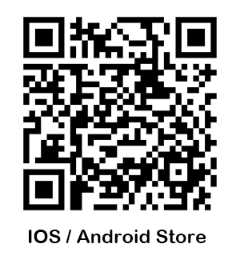from in the menu, register and login to “BBM Camera” APP.
Please note: Using the APP requires authorization for location, microphone, and camera. Therefore, when the authorization prompt pops up during the usage process, please select "Agree".
- WiFi settings on smartphone
Please make sure your smartphone connects to 2.4GHz WiFi when configuring the camera to network( because the camera can be connected to 2.4GHz WiFi only), you can reconnect your smartphone to 5GHz WiFi once the App configuration is completed.

(3) Login to the App to add baby’s information.
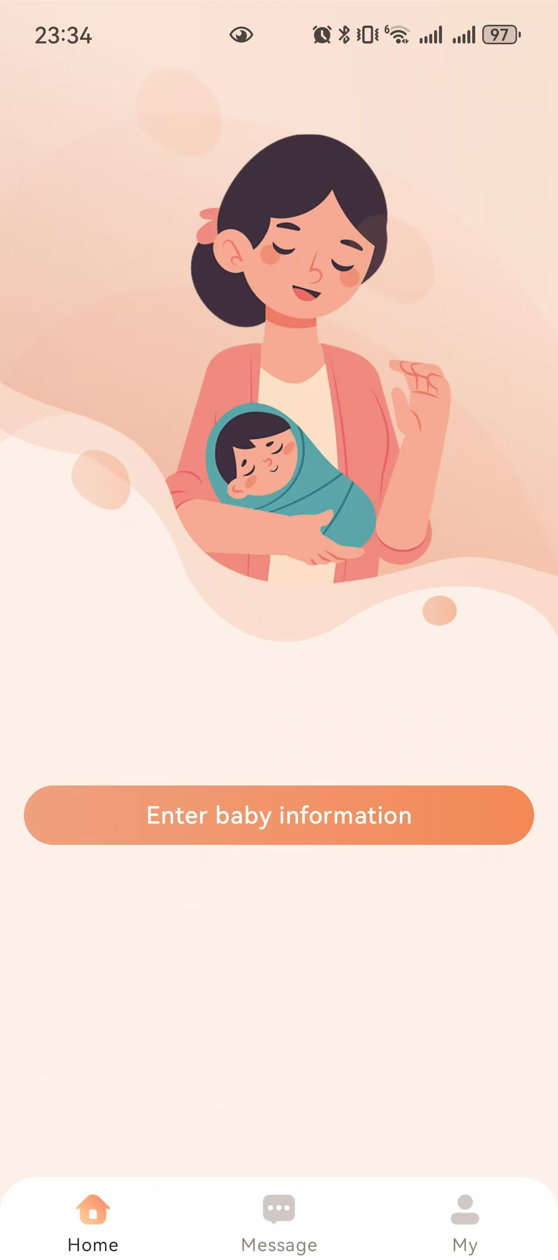 ->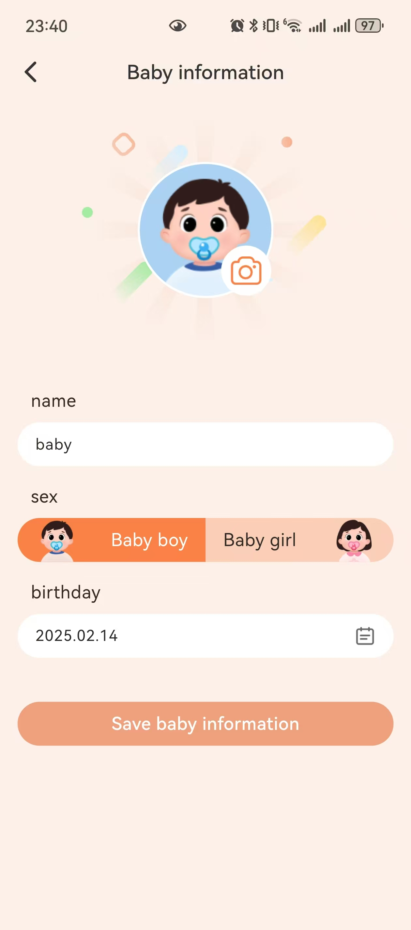->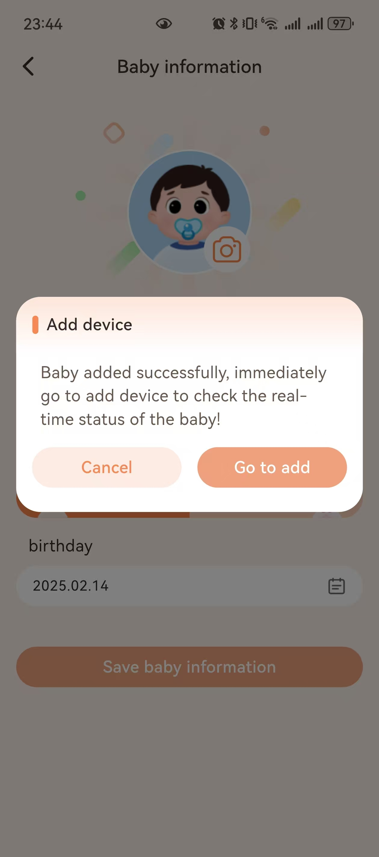->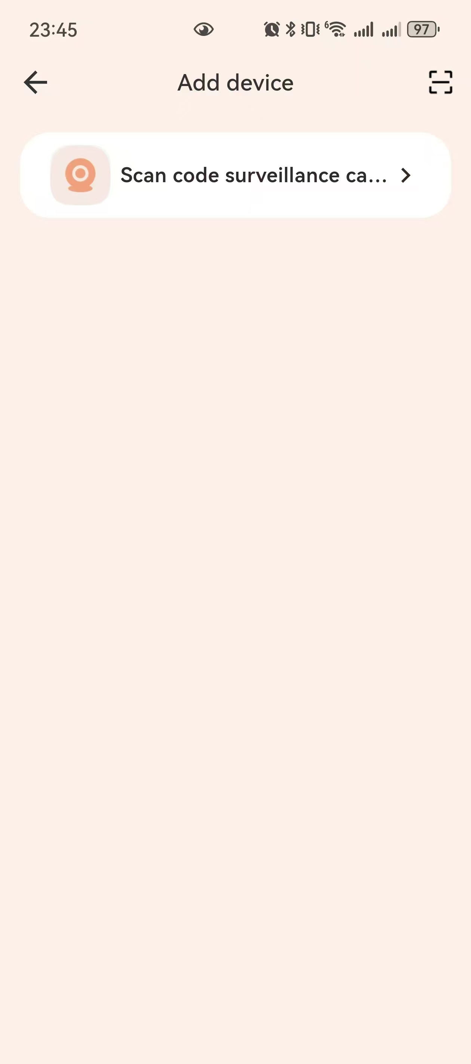->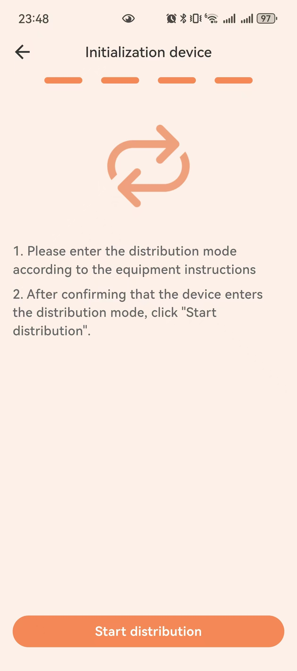->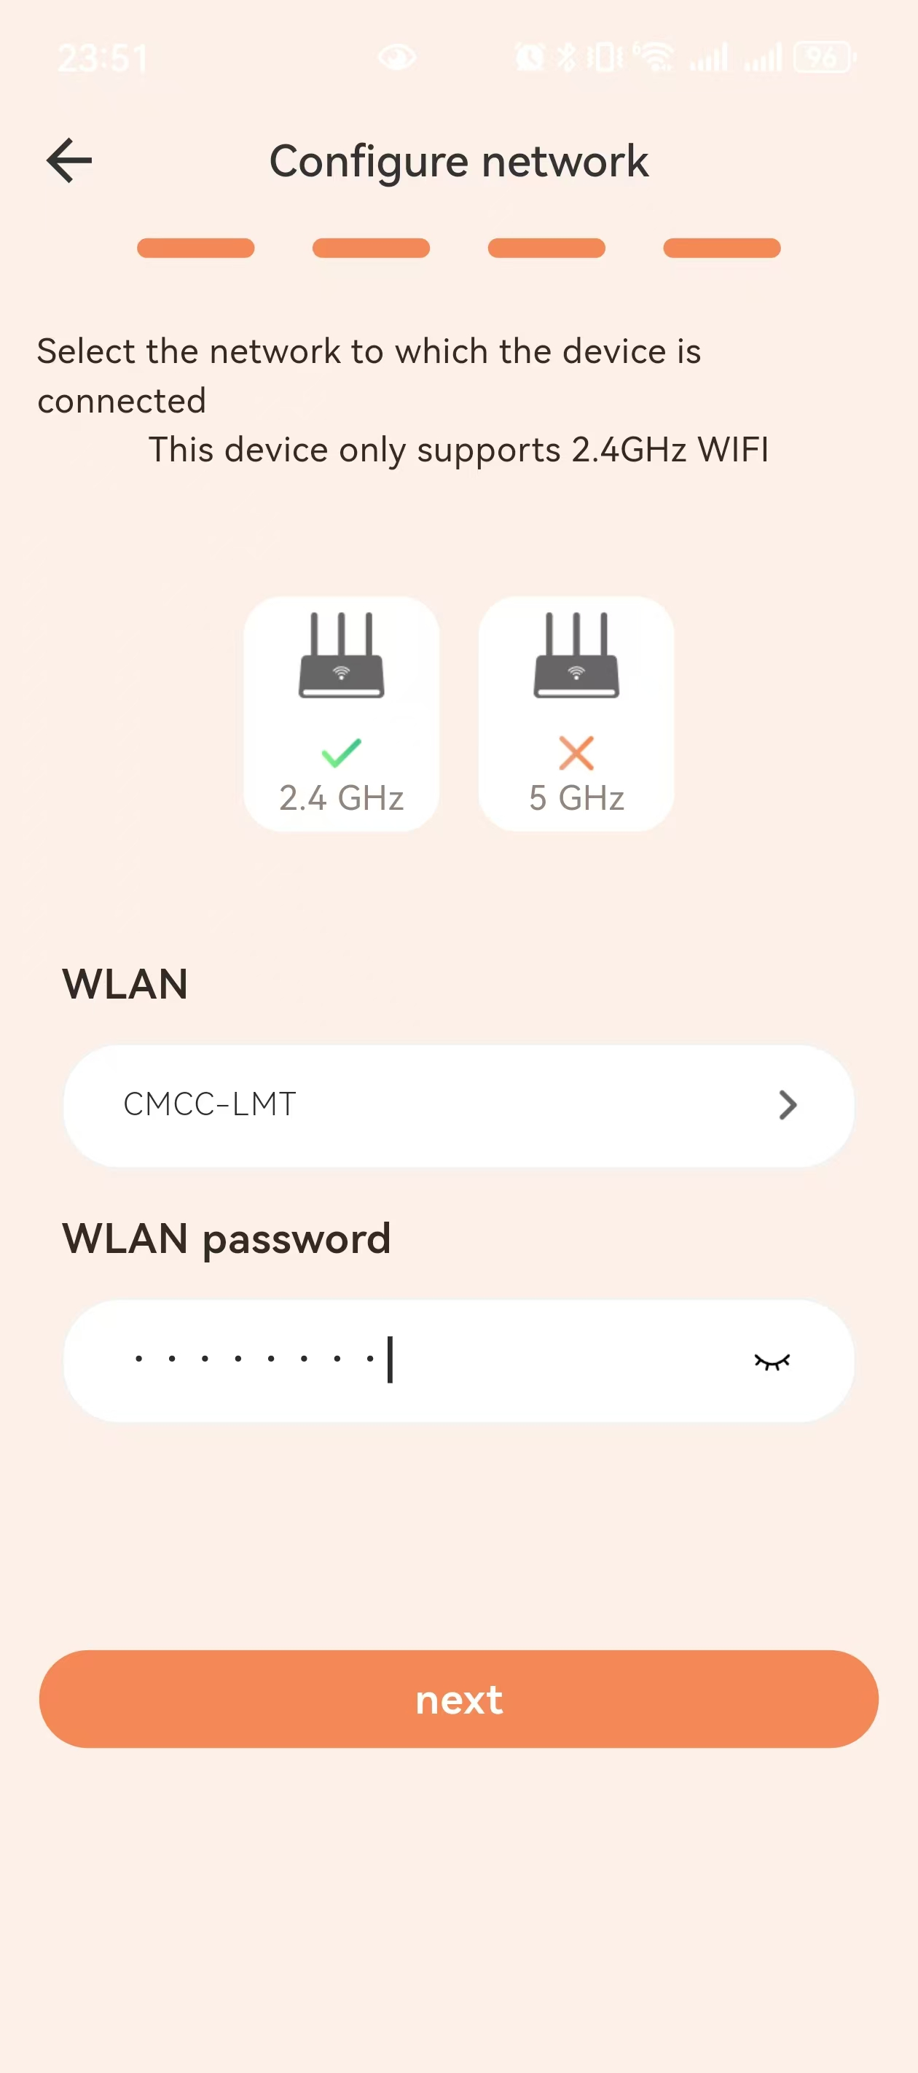->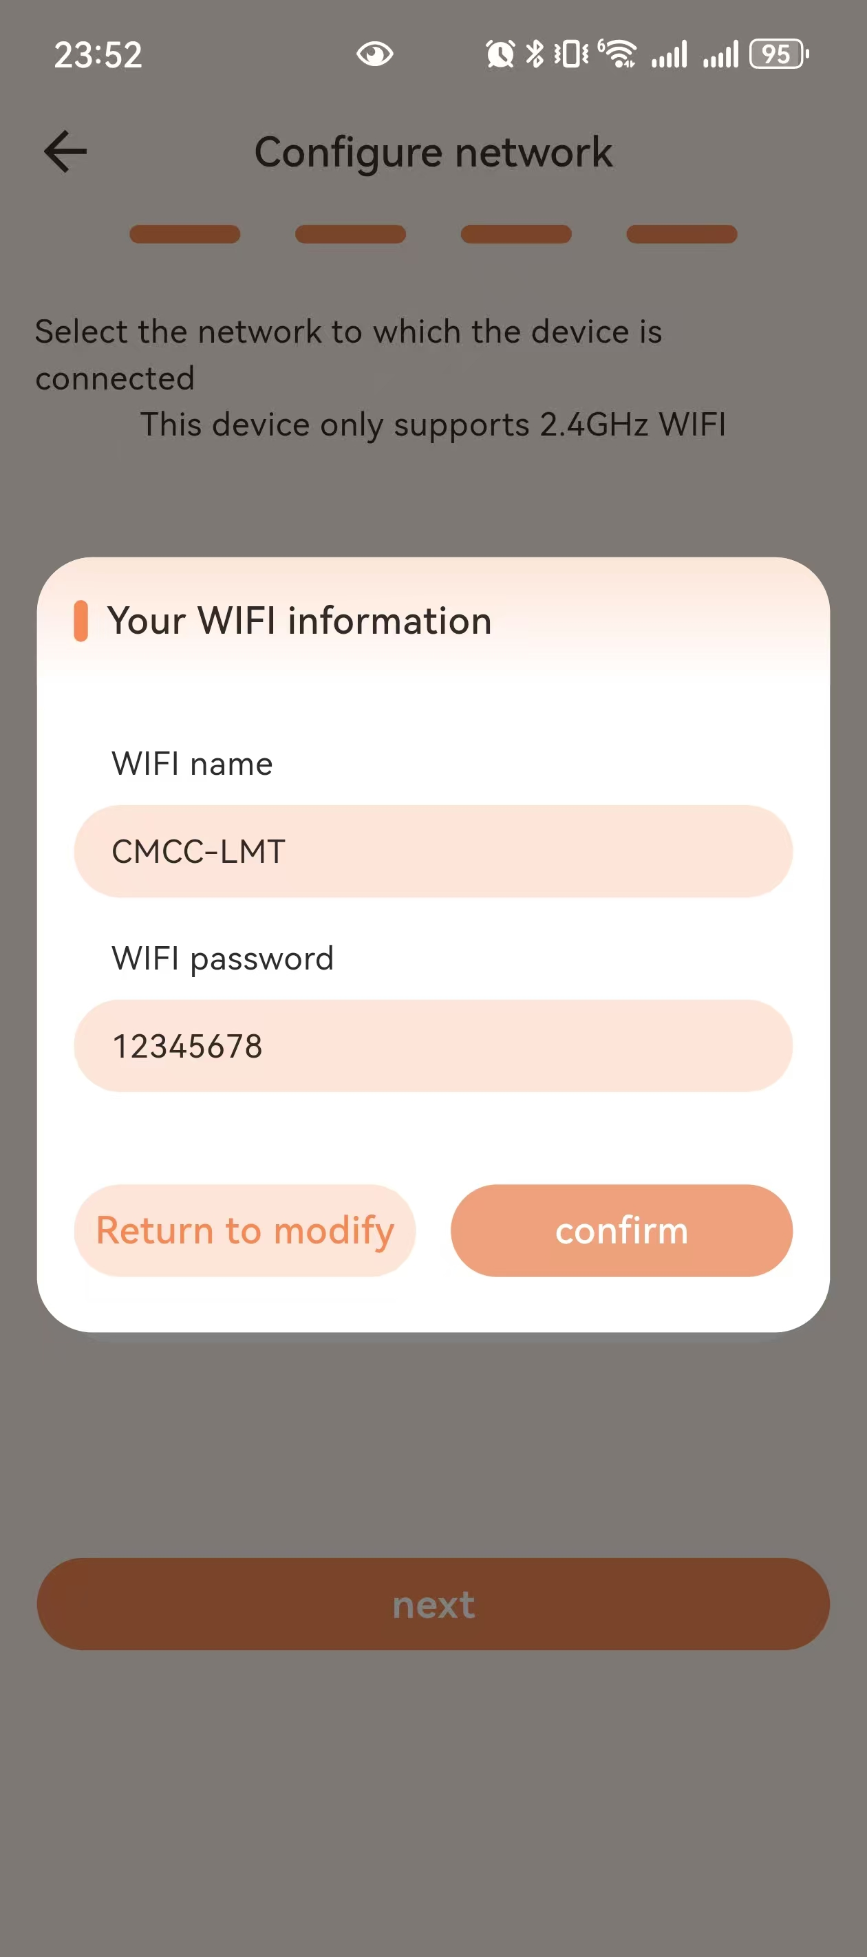 ->
Click ’Confirm’
Click ’next’
Click ’Start distribution’
Click ’Scan code surveillance ...’
Click ‘Go to add’
Enter baby information
Press‘Enter baby information’

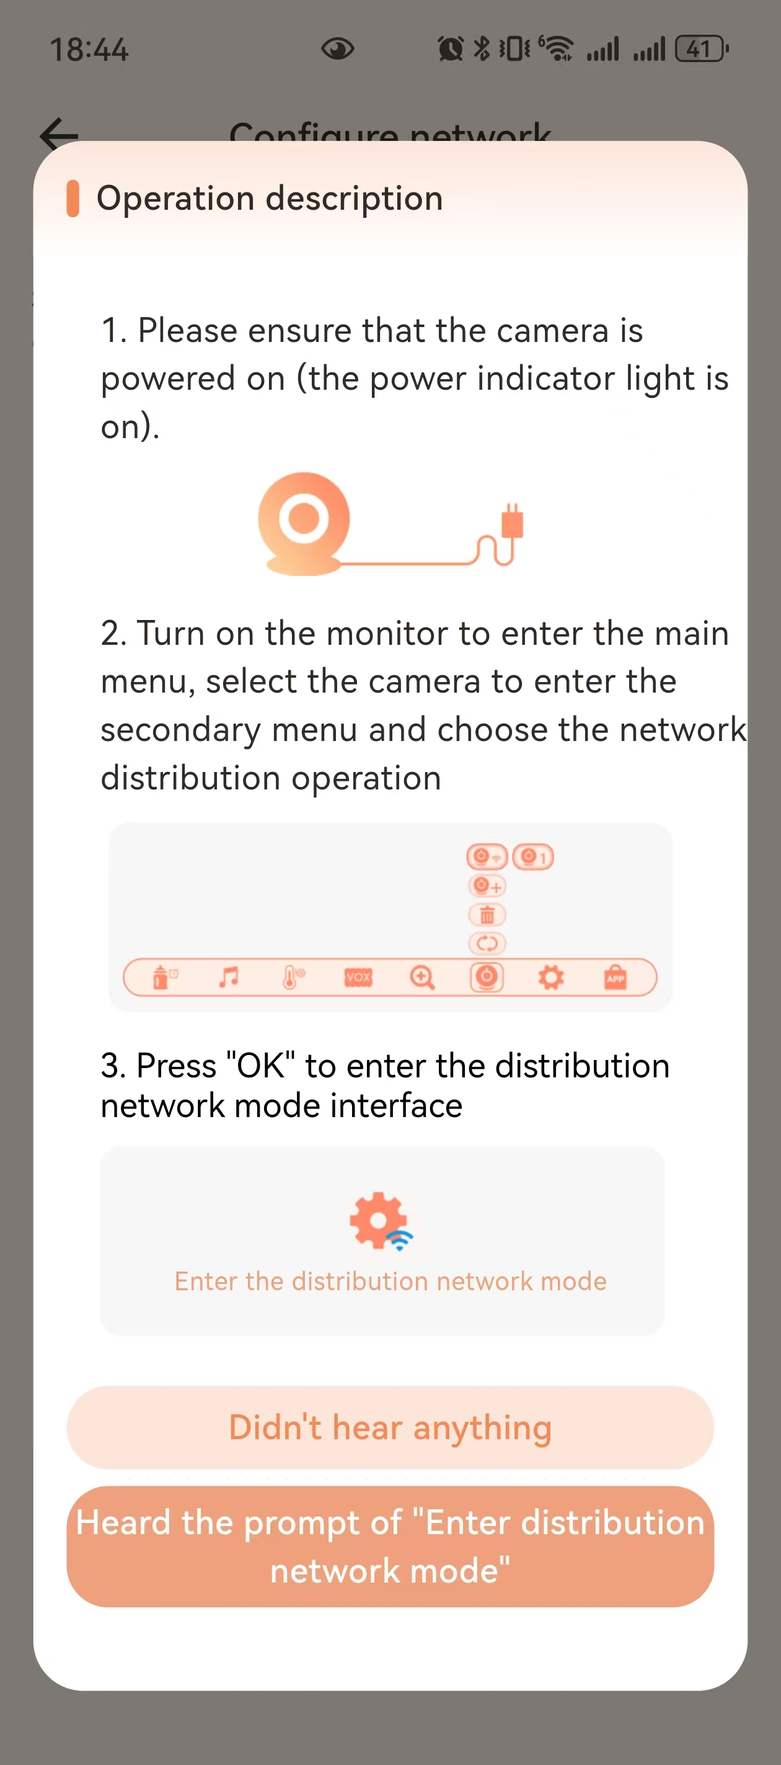-> 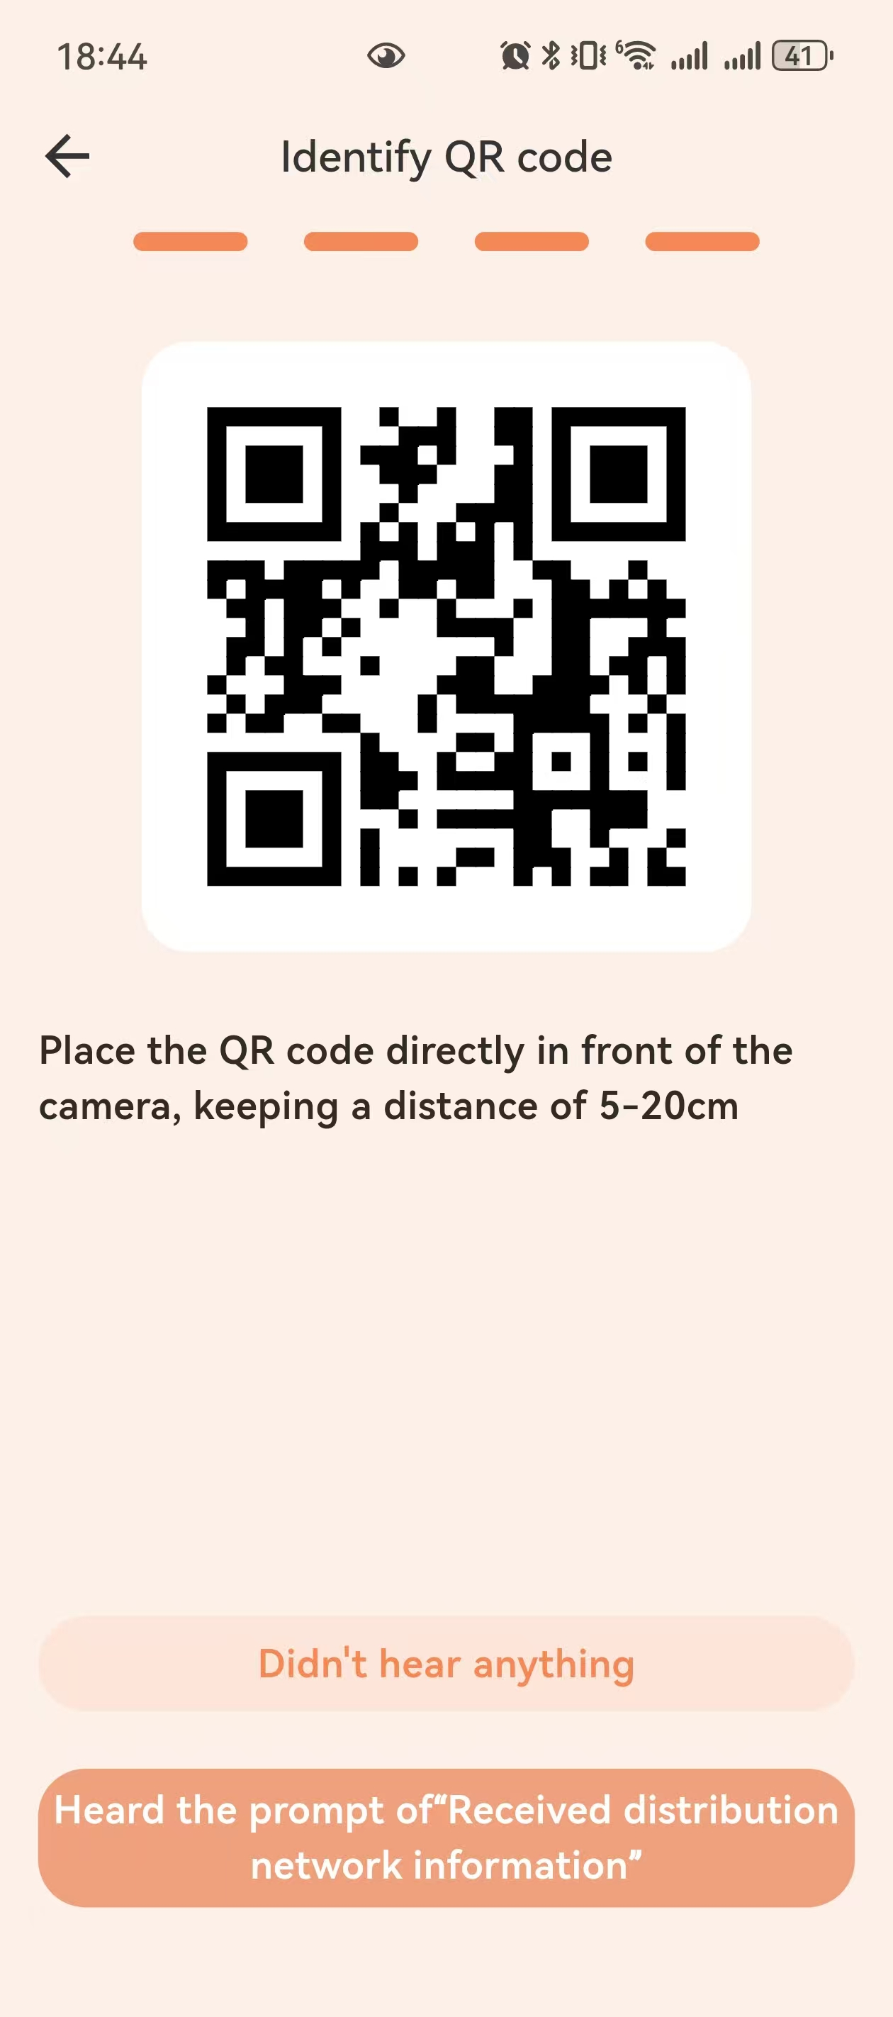
Waiting for pairing
Operation description

(4) Pairing network from the monitor
Turn on the monitor and press menu key to enter the main menu . Pressor to select camera . In the pop-up bar, press button to select ，and press to confirm, press and then press or to chooseor ， select the current camera to enter paring mode, you will see prompt appears on the monitor: 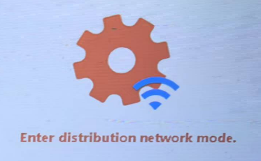 you will hear voice prompt “Enter distribution network mode” from the camera , and you will see the prompt on the monitor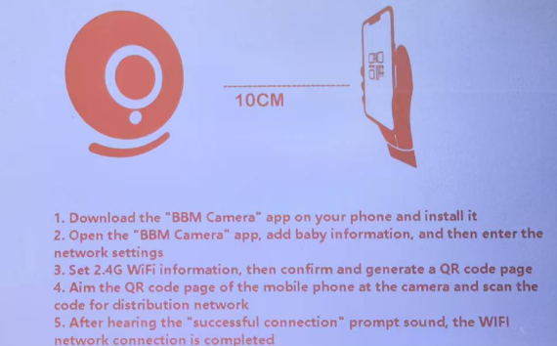，place the QR code against the camera to scan it. (please make sure the distance between the camera and the phone is with 5 to 20cm.)

When you hear“Received distribution network information”click
“Heard the prompt of’Received distribution network information’” ,you will
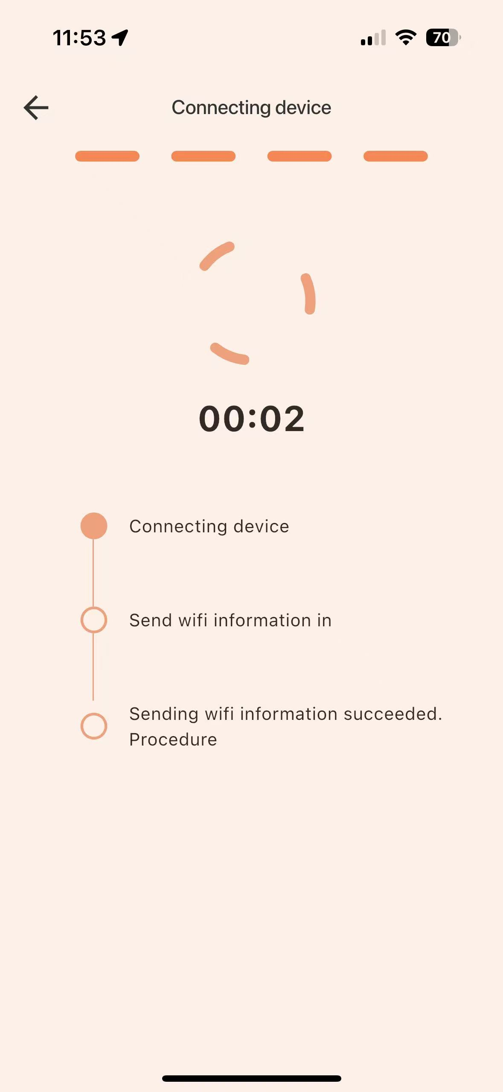

see , when you hear“Network Connection Successful”and when the

following interface appears 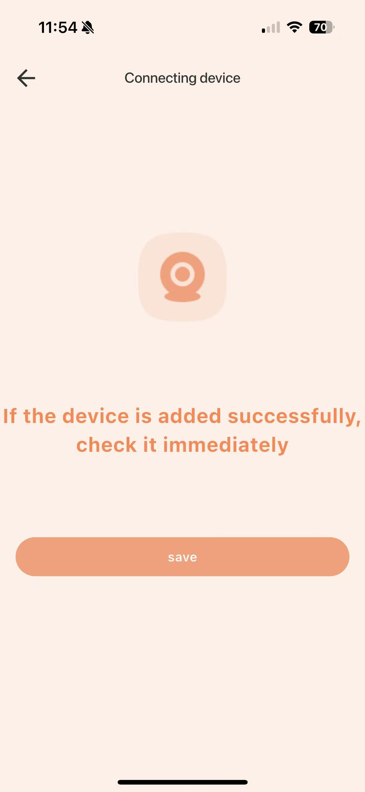 click“Save”，then the network pairing is successful.

(5)If not please double check the WiFi account and password information then try again.
- CAMERA USAGE

3.1 PAIRING BUTTON
Keep pressing pairing button 3 seconds to enter the pairing mode.

3.2 INFRARED LED
The camera is equipped with 1 piece high-intensity infrared LED light, which helps to capture clear images in the dark. When the built-in optical sensor detects that the ambient light is weak, the infrared LED will become automatically light up. The screen of the monitor will be shown in black and white color, and the icon will be displayed in the status bar at the top of the screen.
- BUTTONS OF THE MONITOR

4.1 INTERCOM MODE
While you need talk to your baby, please press and hold it to talk , release when the conversation is over.

4.2 LULLABY
(1)Press the music keyto play the lullaby, and press again to turn off the lullaby.

4.3 CAMERA ROTATION
(1) Press briefly to activate the camera remote control mode, when you see the arrows on screen press the direction button  to adjust the camera rotation angle.
(2) When you are using the menu, press to go back .

4.4 VOLUME ADJUSTMENT
Press or to adjust a larger or smaller volume.The volume has 6 levels for option.

4.5 DISPLAY BRIGHTNESS
Press or to adjust the brightness  directly. It has 6 levels.

5. THE DISPLAYER MENU

5.1 FEEDING REMINDER (ALARM)
Press choose , select the alarm time (0.5h/1h/2h/3h/ 4h) for the feeding reminder, press to confirm. Press to exit the menu.
If the alarm time is set, the monitor will beep every 0.5h/1h/2h/3h/ 4h, and the flashing feeding mark will appear on the screen. Press any key to cancel feeding reminder.

5.2 LULLABY
Press to enter the main menu, select, in the pop-up menu bar, press or to select the lullaby~, press to confirm, When the lullaby is playing thewill be highlighted and the icon becomes , when it stopped playing the icon becomes again.
--Lullaby setting
---Single cycle
---Loop
--- Use or to adjust volume

5.3 TEMPERATURE DISPLAY
- Press to enter the main menu, select , use or to select or , press to confirm.
- Select and pressto enter the sub-menu of setting the alarming temperature.
--- Set the temperature alarm mode
In  mode: The temperature value on the status bar will change color when
the temperature not in the threshold.
In mode: If temperature not in the threshold,the temperature value on the status bar will change color,the screen will appear an icon or prompt also a beep alarm .
--- Set the upper limit of the temperature alarm threshold
Press andto set the temperature value to be warned（℃ setting range 28℃~37℃，℉setting range 82℉~98℉）. If the current ambient temperature is lower than the warning temperature, the system will trigger a temperature warning.
--- Set the lower limit of the temperature alarm threshold
Do the same to set the low warning temperature（℃ setting range 0℃~28℃，℉setting range 32℉~82℉）. If the current ambient temperature is lower than the warning temperature, the system automatically prompts a low temperature warning.
Press any key to cancel Beep sound. If the temperature has not returned to the threshold range, the beep alarm sound will still be emitted 30 seconds later.

5.4 VOX SETTING

5.4.1 VOX mode off:
- Pressto enter the main menu, select and choose to turn off the VOX mode.
- At the status of VOX-off, press the key , the display screen will shut down but the sound from the camera still can be heard at any time. This mode can be used when the baby is playing but the adult needs to leave for a while.

5.4.2 VOX mode on:
Press to enter the main menu, select and choose to turn on VOX mode, the screen and sound will be turned off in 30 seconds. When the ambient sound of the camera is louder than the set value, the display screen will light up and you can hear the sound from the speaker. You can use this mode at night.
The screen will be off in the VOX-on mode, you can press any button to quit VOX mode.

5.5 CAMERAM ZOOM IN
Press choose , select zoom inoror , then press to confirm.

5.6 CAMERA DISPLAY SELECTION
Press choose ，press or to choose , or , then press to enter the sub-menu .
（1）Add camera: Select , then press to choose or for pairing. After the pairing is successful, the monitor will show the image from  or  .
（2）Delete camera: Select to enter delete mode, and then press to delete or ，it will prompt  or , select to delete, select not to delete, if delete successfully, the icon convert to, “no-camera-connection” will be reminded.
（3）Select , then press the key to see the sub-menu, and choose the or to view the corresponding image. Or you can choose to enter cyclic mode, and the image from the cam1 to cam2 will switch in every 15 seconds.
（4）Camera can be placed on the table or hang upside down, you can set the display image direction from the menu.
（5）  For WiFi network configuration, please refer to the details in Section 2.4.

5.7 SETTINGS

5.7.1 Time Settings
Press choose ，select , then press to enter the sub-menu .use or to switch from hour, minute and second，use or to adjust hour, minute and second, press to save the time setting and go back.

5.7.2 Volume Adjustment
. Press choose ，select , press to enter volume control button , press or to make volumn up/down, total 6 levels of volume.
.Press or to adjust the volume  directly. 6 levels can be adjusted.

5.7.3 Brightness Adjustment
. Press choose ，select , press to enter brightness control button ，press or adjust the brightness of the screen.
. Press or to adjust the brightness  directly. 6 levels can be adjusted.

5.7.4 Language Settings
Press choose ，select , press to enter language list，8 languages optional.

5.7.5 Low-power Settings
Press choose ，select , press to select .
---Turn off the low-power mode.
---The monitor screen will automatically dim when no operation made or no moving object was detected in 15 seconds/30 seconds/60 seconds. Press any key to restore the original brightness.

5.7.6 WiFi Switch
Press choose ，select , if WiFi set to  the camera will not connect to internet, no image will show in the phone App, if you need to check the camera image please set WiFi  . Use to turn the WiFi switch of camera or ,press to confirm the settings.

5.7.7 Movement Tracking Switch
Press choose , select , if the status is the auto tracking function is closed, if the status is , when the camera detects any moving objects it will track it automatically. Use to turn the tracking of camera or ,press to confirm the settings.

5.7.8 Light Frequency Settings
Press choose，select ,press to enter light frequency settings, according to different countries the light frequency can be set to 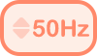 or 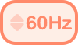. Use to select the frequency and to confirm the settings.

5.7.9 Camera Indicator Light Switch
Press choose , select , press to enter light switch, Use to turn the indicator light of the camera , press to confirm the settings.

6. POWER LEVEL
The mark 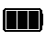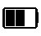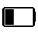shows the current power level, the mark is lower power level and will 5 consecutive beep sound alarming, the beep sound will keep reminding 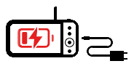.
- SIGNAL
(1) Signal mark . If there is a large signal tower base station or high power signal interference equipments in the current environment, it may cause interference to Transmission and the mark will be appear. When the signal disconnected for 5 seconds, the mark 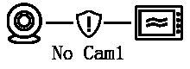 will be appear and flashes, and the monitor will make beep sound for 5 times. After the 5 times of beep sound, the monitor will only leave the mark flashing. Now the monitor is disconnected with the camera.
(2)Camera WiFi signal.If there is no WiFi signal in the current environment, the mark will be appear.

8. CLEANING
Clean the device with a slightly damp cloth or an antistatic wipe. Never use detergents or abrasive solvents.
Cleaning and maintenance
- Do not use thinner, other solvents or chemicals to clean any part of the product, which will damage to the product. This damage is not covered by the warranty.
- Do not expose the product to high temperatures, humidity, or strong sunlight, and do not get it wet.

9. FAQ & TROUBLESHOOTING
1. Q: Why i see “no cam1” on the monitor screen and no image from camera?
A: Mostly it is because the camera is disconnected with the monitor, first please check if the camera is turned on, if yes please go to menu and check the camera connection status, ----, if you see , that means no camera is paired to the monitor, you need to pair the camera with the monitor, follow steps as mentioned in PARING. If you see or, that means the camera is paired to the monitor but disconnected, you can delete the camera and reconnect it, delete steps: ------ or--, then follow steps as mentioned in PARING to re-pair it.
2.Q: Why the signal in the room is bad?
A: a. Check if the receiving antenna of the monitor is turned on;
b. Walls could block the signals, different walls could be made of different materials, so it is possible the signal intensity in different rooms is different, you can try to move the monitor to another place.
3.Q: Why the monitor howling?
A: Please keep the monitor and the camera away from each other for at least 1.5
meters.
4.Q:Why i can’t see any images on screen in a sudden?
A: Please check if the monitor is too close to the camera and if it lost signal, restart the monitor and camera then it can be solved.
5.Q: Why i hear background noise?
A: It could be the sound of electric current and noise from the baby unit.
6.Q: Why the temperature is not precisely shown on the screen?
A: a. The indoor air circulation could cause the difference.
b. The thermistor got ±1℃ deviation, and if any shielding around the thermistor could cause the variation.

10. SPECIFIACATION
Technical Parameter
Model | ABM720S | Display Size | 5-Inch
Camera | 1920*1080P | Transmission method | 2.4GHz FHSS/WiFi
View Angle | 75 Degree | Transmission Distance | 1000 ft(Open Space)
Battery | 5000 mAh | Temperature Detection | Support
Monitor Power Consumption | 1.3W | Cry reminder | Support
Camera Power Consumption | 1.7W | Lullaby | Support
Working Temperature | -20℃~65℃ | Feeding Reminder | Support
Material | ABS | Night Vision | Support
Camera Size | 58.5*50*100mm | Monitor Size | 150*74*17mm(L*W*T)

